P&C Fact or

Fiction?

“The P&C can survive without volunteers.”
Fiction! Without the work of volunteer parents and citizens, there would be no events, no fundraisers, no canteen or uniform shop, and no special, and often crucial, projects to benefit our children.
We

“I should bring a six pack of energy drinks to meetings.”
Fiction! You won’t need them. Our meetings are an hour long. Our motto is: Get in, get it done, go home! We’re all busy parents.
can’t do
it without

“Someone is going to ask me to do something!”
Fact! You are smart, talented and skilled. A P&C would be crazy not to make use of you. Perhaps get in early and volunteer for the job that appeals to you or speaks to your strengths?

Please feel free to contact our P&C for more information.
you!

P&C Name

P&C President
P&C Email: info@pandc.com P&C Tel: 00 0000 0000
join in!
Join us &

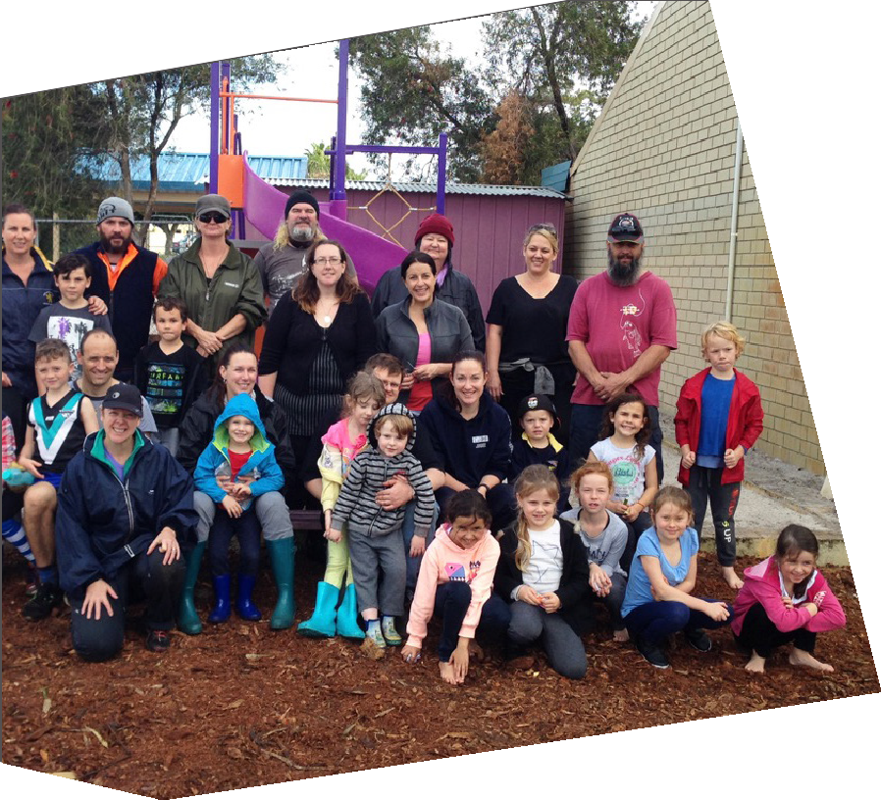

Why is a P&C so important?

Parents & Citizens (P&C) Associations have been recognised in WA legislation for nearly a century. P&Cs are held at a very high level of regard in the WA community.
The goals of P&Cs are:
- to foster strong relationships between the school and the community;
- to help provide resources for the school; and,
- to promote interest in educational matters.
Meeting these goals is a great challenge for all Parents and Citizens in Western Australia!

“The P&C makes the rules as they see fit.”
Fiction! A P&C is a legally recognised Association. They have a set of rules (Constitution) they must follow. Ask for a copy.

“The P&C is run by a clique who boss everyone around and exclude people.”
Fact and Fiction! There are certainly P&Cs out there that do that, but if yours did, would it be handing out this flyer?

“If I take on a role such as Treasurer or Secretary, I won’t have any support or help.”
Fiction! You’ll get support from current members and from WACSSO. WACSSO has councillors and staff to help you. WACSSO also offers FREE training sessions. You don’t have to take on a role now, but perhaps as you become more experienced and comfortable with your P&C, you’ll consider it.
Volunteers do not necessarily have the time; they just have the heart.
I’m a 2-Hour-Vower!

Please fill-in this slip and place it in the box at the front office.

“I vow to give 2 hours of my time each term to help the P&C help our kids.”
Name: Email: Phone:
I am talented at / interested in / prepared to help with:
- arts and crafts  - organising fun!  - gardening/  labouring  - grant writing  - serving in canteen  - graphic design | - social media  - promoting events  - financial stuff  - meeting input  - everything/  anything
I can help at these times:

Day | Morning | Afternoon | Evening
Monday
Tuesday
Wednesday
Thursday
Friday
Weekends
If I was going to attend a P&C meeting the following time of day would be best for me:
Morning | Afternoon | Evening
Please note: we won’t presume you are available on a certain date, we will always check with you first.

