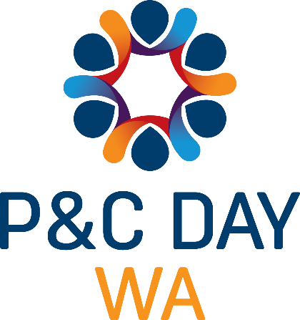
SCHOOL NEWSLETTER TEMPLATE FOR P&C’S TO INCLUDE IN SCHOOL NEWSLETTERS FOR P&C DAY

[School Name] Parents & Citizens’ Association is preparing to celebrate the third annual WA P&C Day on Friday, July 23. P&C day is a special date to recognise, appreciate and celebrate the work P&C Associations do every day to support WA Government school students and schools. We hope you the school community can celebrate P&C Day with us by [insert details on how the school community can be involved]. You can learn more about joining the P&C at any time by finding us on Facebook or emailing P&C President [insert details].

INCLUDE P&C Day logo.

